**CSc 3320: Systems Programming**

Spring 2021

Midterm 1: Total points = 100

Assigned: 26th Feb 2021: 12.01 PM

**Submission Deadline: 2nd Mar 2021: 12.01 PM**

**(No extensions. If your submission is not received by this time then it will NOT be accepted.)**

Submission instructions:

1. Create a Google doc for your submission.

2. Start your responses from page 2 of the document and copy these instructions on page 1.

3. Fill in your name, campus ID and panther # in the fields provided. If this information is missing TWO POINTS WILL BE DEDUCTED.

4. Keep this page 1 intact. If this *submissions instructions* page is missing in your submission TWO POINTS WILL BE DEDUCTED.

5. Start your responses to each QUESTION on a new page.

6. If you are being asked to write code copy the code into a separate txt file and submit that as well. The code should be executable. E.g. if asked for a C script then provide myfile.c so that we can execute that script. In your answer to the specific question, provide the steps on how to execute your file (like a ReadMe).

7. If you are being asked to test code or run specific commands or scripts, provide the evidence of your outputs through a screenshot and/or screen

video-recordings and copy the same into the document.

8. Upon completion, download a .PDF version of the google doc document and submit the same along with all the supplementary files (videos, pictures, scripts etc).

Full Name: Jordan Ballou

Campus ID: jballou1

Panther #:002197414

**Questions 1-5 are 20pts each**

1. Pick any of your 10 favourite unix commands. For each command run the *man* command and copy the text that is printed into a mandatabase.txt. Write a shell script *helpme.sh* that will ask the user to type in a command and then print the manual’s text associated with that corresponding command. If the command the user types is not in the database then the script must print

*sorry, I cannot help you*

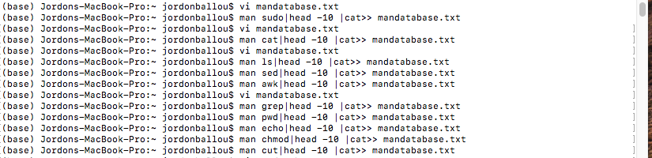

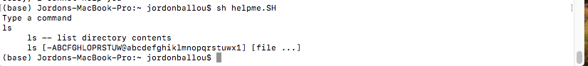

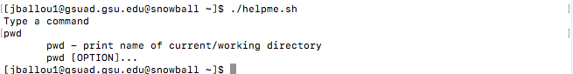

**

1. Pick 10 of your favorite commands and list them down

-sudo,cat,awk,etc

1. Use man followed by pipe command to give both the manual of the command and show what is inside the mandatabase.txt file after executing

-man echo|head -10 |cat >> mandatabase.txt

cat -n mandatabase.txt

1. Then created a shell file called helpme and created a code that prints out the lines of the manual specific to the command using grep

Vim helpme.sh

sh helpme.txt

2. On your computer open your favourite Wikipedia page. Copy the text from that page into a text file **myexamfile.txt** and then copy that file to a directory named **midterm** (use mkdir to create the directory if it doesn’t exist) in your snowball server home directory (use any FTP tool such as Putty or Filezilla to copy the file from your computer to the remote snowball server machine: see Lab 6).

Write a shell script that will find the number of occurrences of a particular keyword typed by the user. Present evidence of your testing with at least 5 trials (different keywords each time)

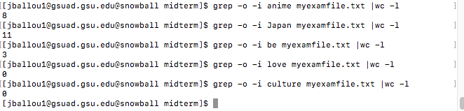

1.create a txt file and insert your wiki page

Cat > myexamfile.txt

2. Create a directory and copy myfileamefile.txt to said directory

Mkdir midterm

Cp myexamfile.txt /midterm

3. Use grep to find how many times a word appears and count it with wc

grep -o -i unix /test/myexamfile.txt | wc -l

3. Write a shell script to find files in a directory hierarchy (e.g. your home directory) that have not been accessed for N days and compress them. Here N is a parameter and the user will be asked for that input as the first step of the script execution.

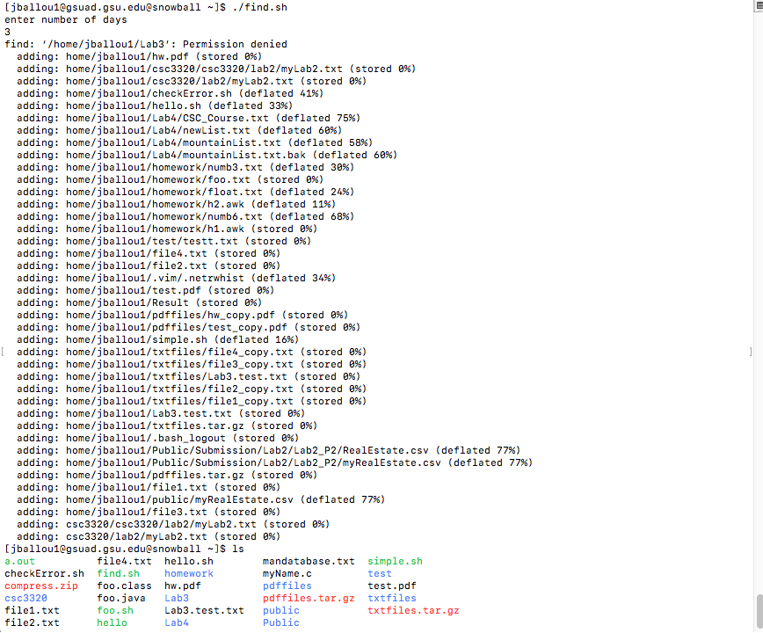

1. Created a shell script to take in input.
2. Uses echo and find to enter the number of days since a file has been opened

Echo “enter the number of days”

find /home -iname "*" -atime +$n -type f | zip compress -@

1. Lastly we zip the files using zip compress -@

4. Build a phone-book utility that allows you to access and modify an alphabetical list of names, addresses and telephone numbers. Use utilities such as awk and sed, to maintain and edit the file of phone-book information. The user (in this case, you) must be able

to read, edit, and delete the phone book contents. The permissions for the phone book database must be such that it is inaccessible to anybody other than the user.

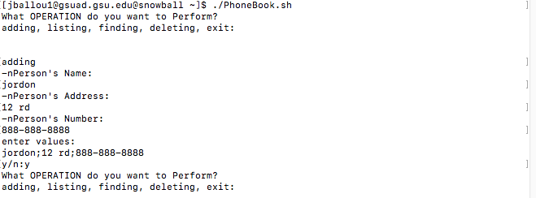

1. First create 5 shells which are named accordingly

-vi adding.sh -vi deleting.sh

-vi subtracting.sh -vi PhoneBook.sh

-vi listing.sh

1. In adding.sh we are mainly just adding entries to our phonebook so all we need is echo,read for the most part

-echo “Name:”

Echo “address:”

Echo “ number:”

And afterwards we add the input values in PhoneBook

1. Listing allows you to jot down the input values and sort them in alphabetical order

-Sort PhoneBook.txt

1. Finding shell is used to search within the phonebook

* Echo “who are you looking for:”

1. Deleting shell deletes the entry specified on which line

* Echo “which line do you want to delete?”

5.

A. Write a C script that will compute the factorial of a given number (positive integer).



1. Uses recursion function to make this happen where n=! 1 is our base case

* Int (factoriall(int n)
* Fact = n*factorial(n-1)

1. Print answer with recursion function call

* printf("Factorial of %d : %d\n",n,factorial(n));

B. Write a C script to find the new integer value of an original integer when it is bit-shifted left by 3 bits and added to its complement (one’s complement of the original integer).

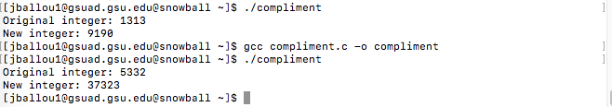

1. Create c script

Vi convert.c

1. Code for finding the new value

int new_integer = ((original_integer) << 3) + (~original_integer);

(Note: You can manually type in the binary representation of the original integer)

(10 bonus points for writing the C script to convert the integer to binary and vice-versa)

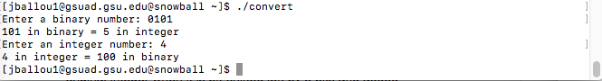

1. Create C shell

* Vi convert.c

(10 bonus points for writing a shell script that will execute both the C scripts from above for a given integer number)